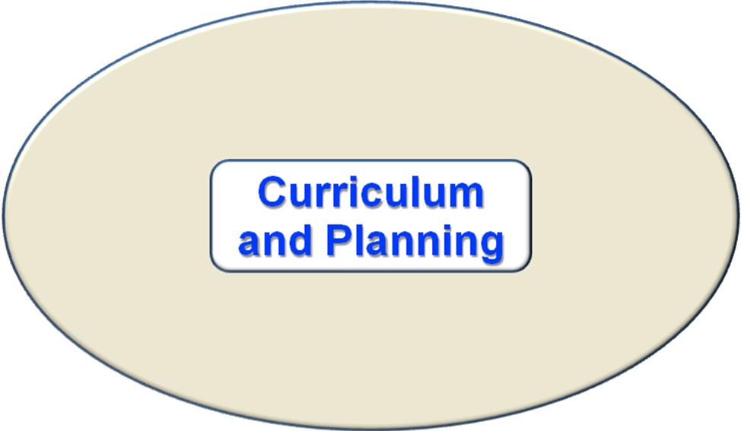

Without looking in the CLASS Keys™ notebook, work in small groups and use this strand graphic to brainstorm or anticipate what you would expect to see as elements (teacher performances) in this strand. Using pages 3-21, compare your ideas to what is in the notebook.

